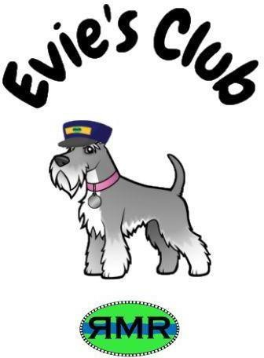

Evie's club is a brand new club for young supporters of RMR up to the age of 12.
Membership of Evie's Club is £10.00 per year and includes a special Evie's club membership card, a pin badge and 5 ride train tickets. In addition you will receive a regular newsletter with printable puzzles and colouring in sheets.
If you would like to join Evie's club please fill in the members details below witha contact email and phone number for their parent or guardian.

First Name:
Last Name:
Email: to be used to contact you for ALL Evie's club correspondence
Address: only used for sending membership card ride tickets and pin badge. For all other correspondence, you will be contacted only by email
Phone No:
Method Of Payment: | Cash/Cheque / BACs Transfer
Please note: we can only send Evie's club newsletters & other correspondence via email.

Membership is valid for one year from 1st date of the joining month. Payment details are overleaf. Renewals not received by the end of the expiry month will be classed as void & all contact details will be deleted.

By becoming a Evie's club do you give your consent for: (please tick if you give permission)
Your contact details to be stored securely by the Evie's club Secretary until you cease to be a member.
The Evie's club Secretary to be able to contact you by phone
The Evie's club Secretary to be able to contact you by email
That RMR may use pictures and/or videos taken of you/your family, in relation to RMR activities for publicity, in press articles and/or on the club website and/or via social media
Our Evie's club Secretary will need to contact you to send newsletters and with news of Evie's club events. In line with the GDPR Law 2018, please indicate below if you give RMR the following permissions.

Payment Details:
Cash: should be posted to the treasurer at the below address with your membership form.

Cheques:
Cheques should be made payable to Riverside Miniature Railway and posted with your application form to the Treasurers address below (or handed it to the RMR ticket office with the application form)

BACs Transfer:
Account Name RIVERSIDE MINIATURE RAILWAY CLUB Bank NATWEST ST. NEOTS
Sort Code 60-18-23
Account Number 18725864
Payment Reference (Initial & surname & Evie's club (B Smith Evie's club for example)
Please email the whole application form to treasurer@riversiderailway.co.uk
Postal address

Mr R Brown RMR Treasurer Evie Club
19 Kimberley Road Chingford
London E4 6DD

