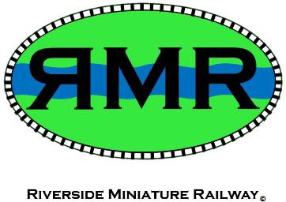

Friends of RMR
We are proud to launch our new scheme Friends of RMR.
Being a Friend of RMR means that you can show your support for our community railway project and contribute towards its future.
Membership of FoRMR is £10.00 per year and includes a membership card and a 5 ride train ticket. In addition you will receive a regular newsletter and invitations to FoRMR events throughout the year.
If you would like to join FoRMR, please fill in your details below.

First Name:
Last Name:
Email: to be used to contact you for ALL FoRMR correspondence
Address: only used for sending 5 ride ticket. For all other correspondence, you will be contacted only by email
Phone No:
Method Of Payment: | Cash / Cheque / BACs Transfer
Please note: we can only send FoRMR newsletters & other correspondence via email.

Membership is renewable annually on 1st December. Payment details are overleaf. Renewals not received by 1st January will be classed as void & all contact details will be deleted.

Our FoRMR Secretary will need to contact you to send newsletters and with news of FoRMR events. In line with the GDPR Law 2018, please indicate below if you give RMR the following permissions.

By becoming a Friend of RMR do you give your consent for: (please tick if you give permission)
Your contact details to be stored securely by the FoRMR Secretary until you cease to be a FoRMR.
The FoRMR Secretary to be able to contact you by phone
The FoRMR Secretary to be able to contact you by email
That RMR may use pictures and/or videos taken of you/your family, in relation to RMR activities for publicity, in press articles and/or on the club website and/or via social media

Payment Details:
Cheques:
Cheques should be made payable to Riverside Miniature Railway and posted with your application form to the Treasurers address below (or handed it to the RMR ticket office with the application form)

Cash:
Paid in at the ticket office at RMR, with the application form

BACs Transfer:
Account Name RIVERSIDE MINIATURE RAILWAY CLUB Bank NATWEST ST. NEOTS
Sort Code 60-18-23
Account Number 18725864
Payment Reference (Your surname & FoRMR i.e Bob Smith FoRMR) Please email the whole application form to treasurer@riversiderailway.co.uk
Postal address
Mr R Brown RMR Treasurer
19 Kimberley Road Chingford
London E4 6DD

